**Sort Python lists using key in Python**

**Using sorted() function:**

The sorted() function returns a sorted list of the specified iterable object.

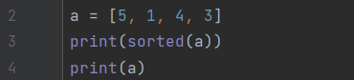

**Output:**



**Using sorted with reverse:**

The sorted() function with reverse in Python is used to sort a sequence (such as a list, tuple) in reverse order.

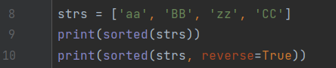

**Output:**



**Sorting with key:**

We can use key in sorted to sort even more precisely.



**Output:**



**Using lower with key:**

Here we passed lower function to sort according to the need.



**Output:**



**Function to key:**

Here we have passed a function to the key. This code will sort based on the last character of the strings in the list.

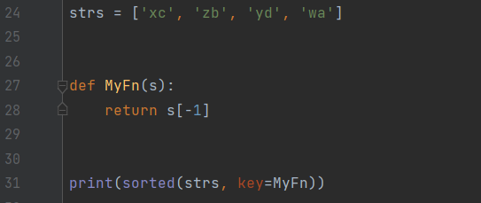

**Output:**



**Sort() method:**

The sort() method will sort the list in ascending order and saves the changes.

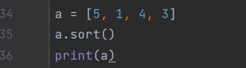

**Output:**

